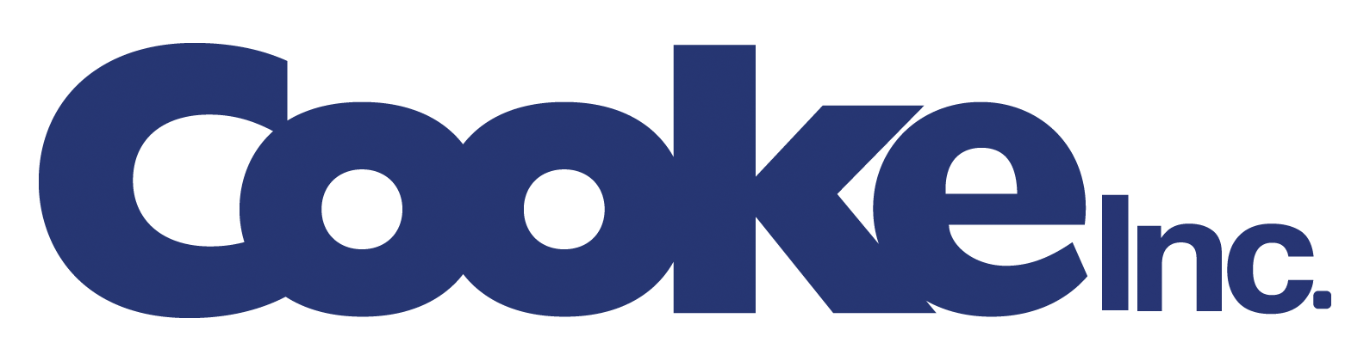

**Cooke Inc. acquires Farallon Aquaculture de Nicaragua S.A.**

**Saint John, New Brunswick, Canada and Leon, Nicaragua – March 16, 2019 –** Cooke Inc. (“Cooke”), a New Brunswick company and parent of Cooke Aquaculture Inc., has acquired Farallon Aquaculture de Nicaragua S.A. (“Farallon Nicaragua”), a vertically integrated producer of farmed shrimp and a leading supplier of branded fresh-frozen shrimp to major markets in Asia, Europe and the U.S.

Farallon Nicaragua is headquartered in Leon, Nicaragua, employs 384 people, and operates a state-of-the-art hatchery, three farms and an onsite processing plant from four locations.

“Farallon Nicaragua is a company guided by the highest international standards in environment, health, security, and quality – all attributes shared with our existing aquaculture and wild seafood fishery divisions,” said Glenn Cooke, CEO of Cooke Inc. “With their long-term expertise in the shrimp market, and emphasis on continuous innovation, Farallon is well positioned to support our expansion in the shrimp market to supply high quality, sustainable seafood.”

In February, Cooke Inc. announced its acquisition of the Seajoy Seafood Corporation group, one of the largest vertically integrated, premium shrimp farmers in Latin America. Seajoy’s organic Pacific white shrimp farms are in Honduras and Nicaragua.

“Farallon Nicaragua also produces Pacific white shrimp and offers Post-larvae (PL) for commercial sale,” added Glenn Cooke. “We will integrate the company into our Seajoy operations, which allows for us to achieve Seajoy’s certifications for producing environmentally and socially responsible seafood from groups such as the GAA (Global Aquaculture Alliance), 4-star BAP (Best Aquaculture Practices), and ASC (Aquaculture Stewardship Council).”

“Over the last two decades we have built a recognized and respected brand and look forward to continued success as part of the Cooke family of companies,” said Jose B. Martinez, founder and owner of Farallon Nicaragua. “We believe this ownership transition will allow Farallon to realize its full potential.”

The terms of the transaction have not been disclosed as both companies are private family-owned businesses. Cooke Inc. was advised by the law firm Morgan, Lewis & Bockius LLP and the accounting firm Deloitte LLP. Farallon Nicaragua was advised by Woodbridge International and the law firm Morgan & Morgan.

Cooke Inc. is showcasing it’s fresh, sustainable True North Seafood Company branded products this week in Boston, MA, at Seafood Expo North America, in booths 1133 & 1233.

**About Cooke Inc.**

The Cooke Inc. family of companies includes global aquaculture divisions including its wholly-owned subsidiary Cooke Aquaculture Inc. and Kelly Cove Salmon Ltd., as well as seafood and wild fishery divisions under Cooke Seafood USA, Inc., Icicle Seafoods, Inc., Wanchese Fish Company, Inc. and Omega Protein Corporation. Cooke Aquaculture Inc. is a vertically-integrated family company based in Blacks Harbour, New Brunswick, Canada, with salmon farming operations in Atlantic Canada, the United States, Chile and Scotland as well as seabass and seabream farming operations in Spain and shrimp farming in Honduras and Nicaragua. Cooke ships fresh, sustainable True North Seafood Company branded products to over 67 countries.

For the second year in a row, Cooke Inc. earned the #1 spot on the SeafoodSource list of Top 10 North American Seafood Suppliers and Cooke Aquaculture Inc. was once again recognized as a Platinum Member of one of Canada’s Best Managed Companies. Cooke Aquaculture Inc. was recently recognized as the top private growth company in Canada by Grant Thornton and the Canadian Chamber of Commerce.

**CONTACT:**

Joel Richardson

Vice President Public Relations

Cooke Inc.

40 Wellington Row, Saint John, NB, Canada E2L 3H3

+1-506-694-4939 office / +1-506-721-1093 mobile

Joel.richardson@cookeaqua.com

Twitter: [@cookeseafood](https://twitter.com/cookeseafood)

Facebook: [www.facebook.com/cookeinc/](http://www.facebook.com/cookeinc/)

LinkedIn: [www.linkedin.com/company/cookeinc](http://www.linkedin.com/company/cookeinc)

Websites: [www.cookeseafood.com](http://www.cookeseafood.com) / [www.truenorthseafood.com](http://www.truenorthseafood.com)